A Parallel Clustering Method Combined Information Bottleneck Theory and Centroid-based Clustering

**Sun Zhanquan1, Geoffrey Fox2, Gu Weidong1**

(1 Key Laboratory for Computer Network of Shandong Province, Shandong Computer Science Center,

Jinan, Shandong, 250014, China

2 School of Informatics and Computing, Pervasive Technology Institute, Indiana University Bloomington,

Bloomington, Indiana, 47408, USA)

[sunzhq@sdas.org](mailto:sunzhq@sdas.org), [gcf@indiana.edu](mailto:gcf@indiana.edu), guwd@sdas.org

## Abstract: Clustering is an important research topic of data mining. Information bottleneck theory based clustering method is suitable for dealing with complicated clustering problems because that its information loss metric can measure arbitrary statistical relationships between samples. It has been widely applied to many kinds of areas. With the development of information technology, the electronic data scale becomes larger and larger. Classical information bottleneck theory based clustering method is out of work to deal with large-scale dataset because of expensive computational cost. Parallel clustering method based on MapReduce model is the most efficient method to deal with large-scale data-intensive clustering problems. A parallel clustering method based on MapReduce model is developed in this paper. In the method, parallel information bottleneck theory clustering method based on MapReduce is proposed to determine the initial clustering center. An objective method is proposed to determine the final number of clusters automatically. Parallel centroid-based clustering method is proposed to determine the final clustering result. The clustering results are visualized with interpolation MDS dimension reduction method. The efficiency of the method is illustrated with a practical DNA clustering example.

Keywords: Clustering; Information bottleneck theory; MapReduce; Centroid-based Clustering

1 Introduction

## Clustering is a main task of explorative data mining, and a common technique for statistical data analysis used in many areas, such as machine learning, pattern recognition, image analysis, information retrieval, bioinformatics and so on. The goal of clustering is to determine the intrinsic grouping in a set of unlabeled data. Some classical clustering methods, such as centroid-based clustering, Fisher clustering method, Kohonen neural network and so on, have been studied and widely applied to many kinds of field [1]. Centroid-based clustering, such as k-mean, k-center and so on, is a kind of important clustering method [2]. It is easy to be used in practice. But it has some shortcomings. The first one is that no objective method is available to determine the initial center, which has great effect on the final clustering results. Another one is that the number of clusters can’t be determined objectively. Furthermore, the distance metric used in centroid-based clustering usually can’t measure the complicated relationships between samples. Information bottleneck (IB) theory was proposed by Tishby [3]. It is a data compression method based on Shannon’s rate distortion theory. The clustering method based on IB theory was widely studied in recent years. The quantity of information loss caused by merging is used to measure the distance between samples. It has been applied to the clustering of image, texture, and galaxy successfully and got good results [4-5]. However, the computation cost of IB clustering is expensive. It will be out of work to deal with large-scale dataset. With the development of electronic and computer technology, the quantity of electronic data increases exponentially [6]. Data deluge has become a salient problem to be solved. Scientists are overwhelmed with the increasing amount of data processing needs arising from the storm of data that is flowing through virtually every science field, such as bioinformatics [7-8], biomedical [9-10], Cheminformatics [11], web [12] and so on. How to develop parallel clustering methods to process large-scale data is an important issue. Many scholars have done lots work on this topic. Efficient parallel algorithms and implementation techniques are the key to meeting the scalability and performance requirements entailed in such large-scale data mining analysis. Many parallel algorithms are implemented using different parallelization techniques such as threads, MPI, MapReduce, and mash-up or workflow technologies yielding different performance and usability characteristics [13]. MPI model is efficient in computation intensive problems, especially in simulation. However, it is not efficient in dealing with data intensive problems. MapReduce is a programming model developed from the data analysis model of the information retrieval field. Several MapReduce architectures are developed, such as Barrier-less MapReduce, MapReduceMerge, Oivos, Kahn process networks and so on [14]. But all these MapReduce architectures don’t support iterative Map and Reduce tasks, which is required in many data mining algorithms. An iterative MapReduce architecture software Twister is developed by Fox. It supports not only non-iterative MapReduce applications but also iterative MapReduce applications [15]. It can be used in data intensive data mining problems. Some clustering methods based on MapReduce were proposed, such as k-means, EM, Dirichlet process clustering and so on. Though the clustering method based on IB theory is efficient in processing complicated clustering problem, it can’t be transformed to MapReduce model directly. Furthermore, the number of clusters of IB clustering should be determined manually according to an objective rule. It can’t be operated automatically.

The evaluation of unsupervised clustering result is a difficult problem. Visualization is a good mean to improve it. However, in practical, many problems’ feature variable vectors are in high dimensions. Feature extraction can decrease the dimension of input efficiently. Many feature extraction methods have been proposed, such as Principal Component Analysis (PCA), Self Organization Map (SOM) network, and so on [16-17]. Multidimentional Scaling (MDS) is a kind of Graphical representations method of multivariate data [18]. The method is based on techniques of representing a set of observations by a set of points in a low-dimensional real Euclidean vector space, so that observations that are similar to one another are represented by points that are close together. It is a nonlinear dimension reduction method. The computation complexity is and memory requirement is . With the increase of sample size, the computation cost of MDS increase sharply. For improving the computation speed, interpolation MDS are introduced in [19]. It is used to extract features from large-scale data. In this paper, interpolation MDS is used to reduce the feature dimension.

In this paper, a novel clustering method based on MapReduce is proposed. It combines parallel IB theory clustering with parallel centroid based clustering. Firstly, IB theory based hierarchy clustering is used to determine the centroid of each Map computational node. An objective method is proposed to determine the number of clusters.All sub-centroids are combined into one centroid with the IB theory also in Reduce computational node. The centroid is taken as the initial center of centroid based clustering method. For measuring the complicated correlation between samples, information loss is used to measure the distance in the centroid based clustering method. The clustering method is programmed with iterative MapReduce model Twister. For visualizing the clustering results, interpolation MDS is used to reduce the samples into 2 or 3 dimensions. The reduced clustering results are shown in 3D coordination with Pviz software developed by Indiana University. A DNA clustering example is analyzed with the proposed method to illustrate the efficiency.

The rest of the paper is organized as follows. Parallel IB theory based on MapReduce will be introduced in detail in Section 2. The parallel clustering method based on centroids clustering will be described in detail in Section 3. Interpolation MDS dimension reduction method is introduced in Section 4. A DNA analysis example is analyzed in Section 5. At last, some conclusions are drawn.

**2 Parallel IB Clustering**

**2.1 IB Principle**

The IB clustering method states that among all the possible clusters of a given object set when the number of clusters is fixed, the desired clustering is the one that minimizes the loss of mutual information between the objects and the features extracted from them [3]. Let be a joint distribution on the “object” space and the “feature” space . According to the IB principle we seek a clustering such that the information loss is minimized. is the mutual information between and

(1)

The loss of the mutual information between and caused by the clustering can be calculated as follows.

(2)

Let  and  be two clusters of symbols, the information loss due to the merging is

(3)

Standard information theory operation reveals

(4)

Where , denotes the cardinality of , denotes the cardinality of object space ,, and is the probability density of in cluster .

It assumes that the two clusters are independent when the probability distribution is combined. The combined probability of the two clusters is

(5)

The minimization problem can be approximated with a greedy algorithm. The algorithm is based on a bottom-up merging procedure and starts with the trivial clustering where each cluster consists of a single data vector. In each step, the two clusters with minimum information loss are merged. The method is suitable to both sample clustering and feature clustering.

**2.2 Determine the number of clusters**

The number of final clusters usually is prescribed subjectively in many clustering methods. For avoiding the subjectivity, IB theory based clustering method provides an objective rule to determine it. The clustering process of IB is iterative and each step has an information loss value. The number of clusters corresponding to the iterative step whose information loss changes markedly is taken as the final number of clusters. Although the determination rule in IB theory based clustering is objective, the judgment of information loss change is done manually. It is inconvenient to be operated in parallel clustering. An objective judgment method is proposed to determine the final step whose information loss change markedly. The method is described as follows.

Suppose the information loss of previous steps were known, the information loss value of current step is estimated with least square regression method. The clustering procedure will stop when the difference between estimated and practical information loss value is greater than a threshold value whose value range is [0-1]. The value can be prescribed according to practical problems.

1）Least Square Regression

Linear regression finds the straight line that best represents observations in a [bivariate](http://stattrek.com/Help/Glossary.aspx?Target=Bivariate%20data) data set. Suppose *Y* is a dependent variable, and *X* is an independent variable. The regression line is

(6)

where is a constant, is the regression coefficient, is the value of the independent variable, and is the value of the dependent variable. Given a random sample of observations, the population regression line is estimated by

(7)

After introducing the lagrange coefficient, the optimum solution of the equation is

(8)

(9)

According to the optimum parameter and , the estimated information loss of current step is

(10)

2) Determination of the number of clusters

In the regression, clustering step is taken as and each step’s information loss value is taken as . The difference between estimated value and the practical information loss value is measured with the following equation.

(11)

Clustering procedure will stop when . A clustering example based on the procedure can be shown as in figure 1. There are 100 samples in total. The threshold value of is set 0.9. The *X* axis denotes the clustering step and *Y* axis denotes the information loss value. After calculation, the difference value of step 94 is greater than the threshold value. Then we can obtain the clustering number 6 automatically.

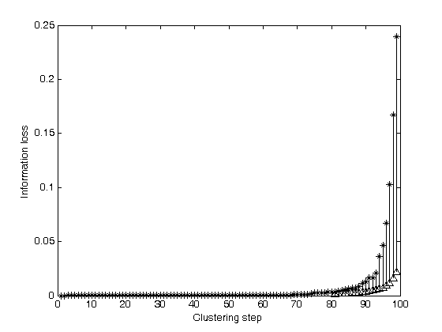

Fig. 1 The clustering procedure based on information bottle-neck theory

**2.3 Parallel IB based on MapReduce**

Given a dataset *D* with *n* samples, it is divided into *m* partitions with samples separately. Apply the clustering method introduced as above to each partition . We can obtain the sub-centroids . All sub-centroids are collected together to generate new data set . After applying the proposed clustering method to the new dataset, we can obtain the initial global center and the number of clusters . From Eq. (5), the cardinality of each cluster is required. The sample size of each sub-centroid should be saved so that they can be used to calculate the final clustering result. The parallel calculation process based on MapReduce is shown in figure 2. Firstly, partitioned datasets are deployed to each computational node evenly. In each Map computational node, apply IB theory based clustering method to each sub dataset to obtain the sub-centroid. All sub-centroids are collected in Reduce node to generate a new dataset. Apply IB theory based clustering method to the new dataset to generate the initial centroid of the global dataset.



Fig. 2 The calculation process of parallel IB based on MapReduce

**3 Parallel centroid clustering based on iterative MapReduce**

After the initial center being calculated, it is used to calculate the final centroid. The process is as follows. Firstly, calculate the distance between each sample **,** , and all the centers of the centroids . In the calculation, information loss (4) is taken as the distance measure. Let be empty dataset. The sample will be added to dataset if the distance between and center vector is the minimum. Recalculate the centroids of computational node with the datasets according to (5). After calculating the new sub-centroids , the update centroid can be calculated according to the following equation.

(12)

The iteration procedure will stop when the difference between the old centroids and the new generated centroids is less than the threshold value . The difference between two iterations is measured with Kull-back divergence, i.e.

(13)

The iteration process of parallel centroid clustering based on MapReduce is shown as in figure 3. Firstly, initial sample dataset is partitioned and deployed to each computational node. The initial centroids obtained with parallel IB are mapped to each computational node. In each Map computational node, the sub-centroids are recalculated with centroid based clustering method introduced as above. All sub-centroids are collected in Reduce computational node and the global centroid is updated according to (12). The new centroids are feedback to main computational node and the difference is calculated according to (13). Iteration will stop when the difference is less than the prescribed threshold value .



Fig.3 The calculating process of parallel centroid based clustering method

**4 Interpolation MDS**

To visualize the clustering results, high dimensional samples should be mapped into 2 or 3 dimensions. MDS is an efficient dimension reduction method. It is as follows[19].

**4.1 Multidimensional Scaling**

MDS is a non-linear optimization approach constructing a lower dimensional mapping of high dimensional data with respect to the given proximity information based on objective functions. It is an efficient feature extraction method. The method can be described as follows.

Given a collection of objects on which a distance function is defined as, the pairwise distance matrix of the objects can be denoted by

where is the distance between and . Euclidean distance is often adopted.

The goal of MDS is, given Δ, to find vectors () to minimize the STRESS or SSTRESS. The definition of STRESS and SSTRESS are as follows.

(14)  
 (15)

where , is a weight value (), is a Euclidean distance between mapping results of and *.* It may be a metric or arbitrary distance function. In other words, MDS attempts to find an [embedding](http://en.wikipedia.org/wiki/Embedding) from the objects into such that distances are preserved.

**4.2 Interpolation MDS**

One of the main limitations of most MDS applications is that it requires memory as well as computation. It is difficult to process MDS with large-scale data set because of the limitation of memory limitation. Interpolation is a suitable solution for large-scale MDS problems. The process can be summarized as follows.

Given *n* samples data in *N* dimension space, *m* samples are selected to be mapped into *L* dimension space with MDS. The other samples will be mapped into *L* dimension space with interpolation method.

Select one sample data and calculate the distance between the sample data and the pre-mapped samples . Select the nearest neighbors , where , who have the minimum distance values. After data set being selected, the mapped value of the input sample is calculated through minimizing the following equations as similar as normal MDS problem with points.

(16)

In the optimization problems, only the position of the mapping position of input sample is variable. According to reference [10], the solution to the optimization problem can be obtained as

(17)

where and is the average of *k* pre-mapped results. The equation can be solved through iteration. The iteration will stop when the difference between two iterations is less than the prescribed threshold values . The difference between two iterations is

(18)

**5 Example: DNA Sequence Clustering**

**5.1 Data source**

Dr. Mina Rho in Indiana University provided some 16S rRNA data that can be downloaded from <http://salsahpc.indiana.edu/millionseq/mina/16SrRNA_index.html>. 100000 DNA data are selected to be used clustering analysis. DNA sequences are usually denoted by four letters, i.e. A, C, G, T [20]. A DNA sequence can be taken as a nonempty string of letter set , i.e. , where denotes the length of the string. A DNA can be expressed with the frequency character of 4 letters and the frequency distribution of double sequence nucleic acid, i.e. adjacent two nucleic acids are composed into a string. The frequency character of double sequence nucleic acid extracted from a DNA sequence can compose a 16 dimension vector The frequency of each vector can be calculated as the formula [21]

(19)

where denotes the frequency of some double sequence nucleic acid in a DNA string. denotes the length of the DNA sequence. In the above formula, the nucleic acids except the head and end of the string are calculated two times. For removing the effect of single nucleic acid, the frequency of double nucleic acid is modified by

(20)

For calculating the information loss, the frequency should be normalized, i.e.

(21)

The sample strings are transformed into 16 dimensions vector. They are described with probabilities and taken as the initial clustering dataset.

The example is analyzed in India cluster node of FutureGrid. Eucalyptus platform is adopted to configure the MapReduce computation environment. Twister0.9 software is deployed in each computational node. ActiveMQ is used as message broker. The configuration of each virtual machine is as follows. Each node installs Ubuntu Linux OS. The processor is 3GHz Intel Xeon with 10GB RAM.

**5.2 DNA sequence clustering**

The initial sequence dataset is partitioned into 100 sections and each section includes 1000 samples. They are deployed to each computational node evenly. Apply parallel IB theory based clustering to each section. The parameters are set as , and . Reduce computational node is used to combine all the sub-centroids into one centroid. We got the initial centroids and the clustering number is determined as 6.

Centroids are are mapped to each computational node. Recalculate the centroid of each partition according to the section 4.2 iteratively. The difference value reaches the threshold value after 5 iterations. We can obtain the final centroids .

C={(0.0610 0.0701 0.0701 0.0486 0.0705 0.0554 0.0663 0.0617 0.0452 0.0729 0.0661 0.0619 0.0677 0.0573 0.0480 0.0762); (0.0597 0.0525 0.0732 0.0670 0.0670 0.0666 0.0534 0.0617 0.0541 0.0615 0.0695 0.0640 0.0661 0.0648 0.0595 0.0586); (0.0514 0.0602 0.0828 0.0568 0.0704 0.0610 0.0654 0.0559 0.0534 0.0642 0.0539 0.0746 0.0698 0.0636 0.0514 0.0643); (0.0662 0.0579 0.0802 0.0499 0.0726 0.0649 0.0599 0.0529 0.0384 0.0648 0.0666 0.0750 0.0658 0.0603 0.0485 0.0752); (0.0596 0.0764 0.0579 0.0532 0.0699 0.0619 0.0574 0.0617 0.0643 0.0541 0.0641 0.0690 0.0529 0.0591 0.0718 0.0661); (0.0616 0.0656 0.0806 0.0459 0.0711 0.0559 0.0608 0.0648 0.0457 0.0616 0.0565 0.0803 0.0665 0.0672 0.0561 0.0590)}

For comparison, the 100 sections are deployed to 1, 2, 4 and 8 computational nodes respectively. The computation times are listed in table1.

Table 1 computation time of parallel IB based on 100 partitions

|  |  |  |  |  |
| --- | --- | --- | --- | --- |
| Node number | 1 | 2 | 4 | 8 |
| Computation time(s) based on 100 partitions | 3256 | 1742 | 883 | 441 |

From table 1 we can find that the computation time decreases markedly when the number of computational node increases. It shows that parallel clustering method based on MapReduce is scalable. For illustrating the affection of different partition scheme, the initial dataset are portioned into 50 sections. When the dataset is partitioned into 50 sections, each section includes 2000 samples. We got the final centroids . When the dataset is not partitioned, the clustering can’t be operated because of RAM limitation.

C={(0.0611 0.0720 0.0719 0.0447 0.0721 0.0561 0.0649 0.0608 0.0446 0.0702 0.0668 0.0643 0.0665 0.0569 0.0475 0.0787); (0.0560 0.0584 0.0813 0.0591 0.0610 0.0574 0.0647 0.0685 0.0392 0.0784 0.0684 0.0584 0.0864 0.0610 0.0390 0.0619); (0.0647 0.0633 0.0593 0.0620 0.0685 0.0551 0.0722 0.0588 0.0478 0.0794 0.0631 0.0570 0.0644 0.0585 0.0538 0.0714); (0.0566 0.0600 0.0820 0.0539 0.0711 0.0613 0.0634 0.0563 0.0487 0.0640 0.0569 0.0759 0.0681 0.0634 0.0517 0.0660); (0.0601 0.0525 0.0732 0.0667 0.0673 0.0668 0.0531 0.0613 0.0540 0.0614 0.0694 0.0644 0.0655 0.0646 0.0599 0.0591); (0.0596 0.0764 0.0580 0.0530 0.0699 0.0618 0.0574 0.0618 0.0643 0.0540 0.0640 0.0691 0.0529 0.0592 0.0717 0.0660)}

The computation times based on 1, 2, 4 and 8 computational nodes are listed in table 2.

Table 2 computation time of parallel IB based on 50 partitions

|  |  |  |  |  |
| --- | --- | --- | --- | --- |
| Node number | 1 | 2 | 4 | 8 |
| Computation time(s) | 16018 | 8132 | 4174 | 2201 |

From table 1 and table2, we can find that computation cost increases markedly when the size of each partition increases. It shows that the parallel clustering method based on MapReduce is efficient in decreasing computation cost.

**5.3 Visualization of clustering result**

The feature dimension of the initial dataset is 16. For visualizing the clustering result, the initial dataset are mapped into 2D and 3D with interpolation MDS respectively. In this example, 4000 samples are selected and mapped into 2D and 3D space with MDS method. The distance matrix of the 4000 samples is calculated firstly according to Euclidean distance. Other samples are mapped into 2D and 3D with interpolation MDS method. In the calculation, the number of nearest neighbor is set . After dimension reduction, the clustering results are visualized with the dimension reduction results. The clustering results of 100 partitions are shown in 2D and 3D as in figure 4 and 5 respectively.

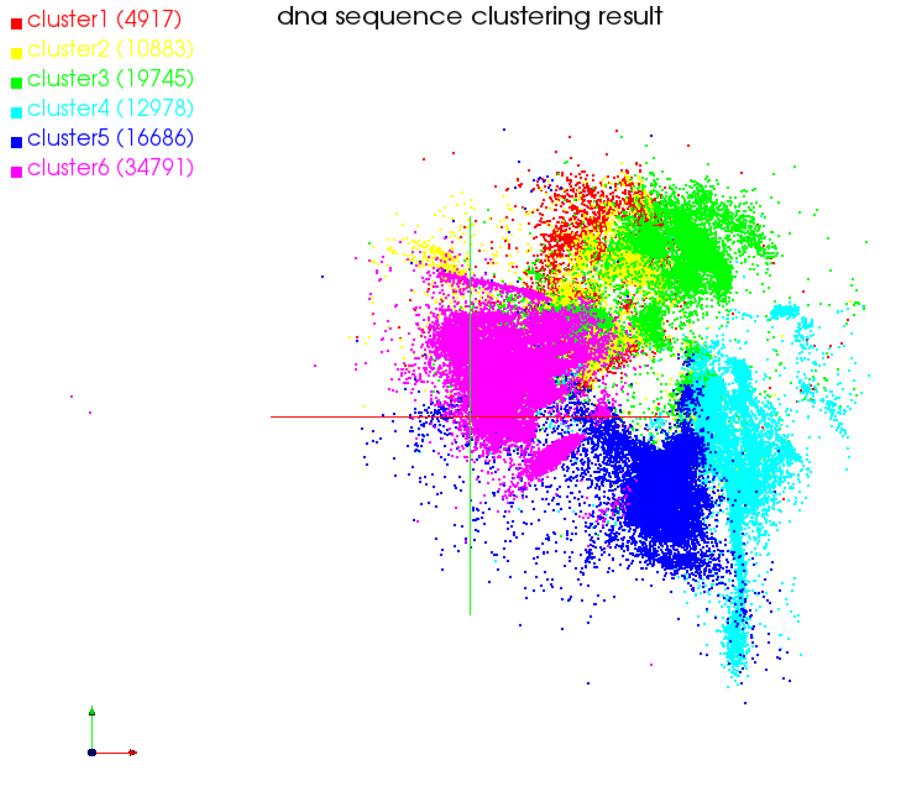

Fig. 4 2D clustering results based on combination of information bottle-neck theory and interpolation MDS corresponding to 100 partitions

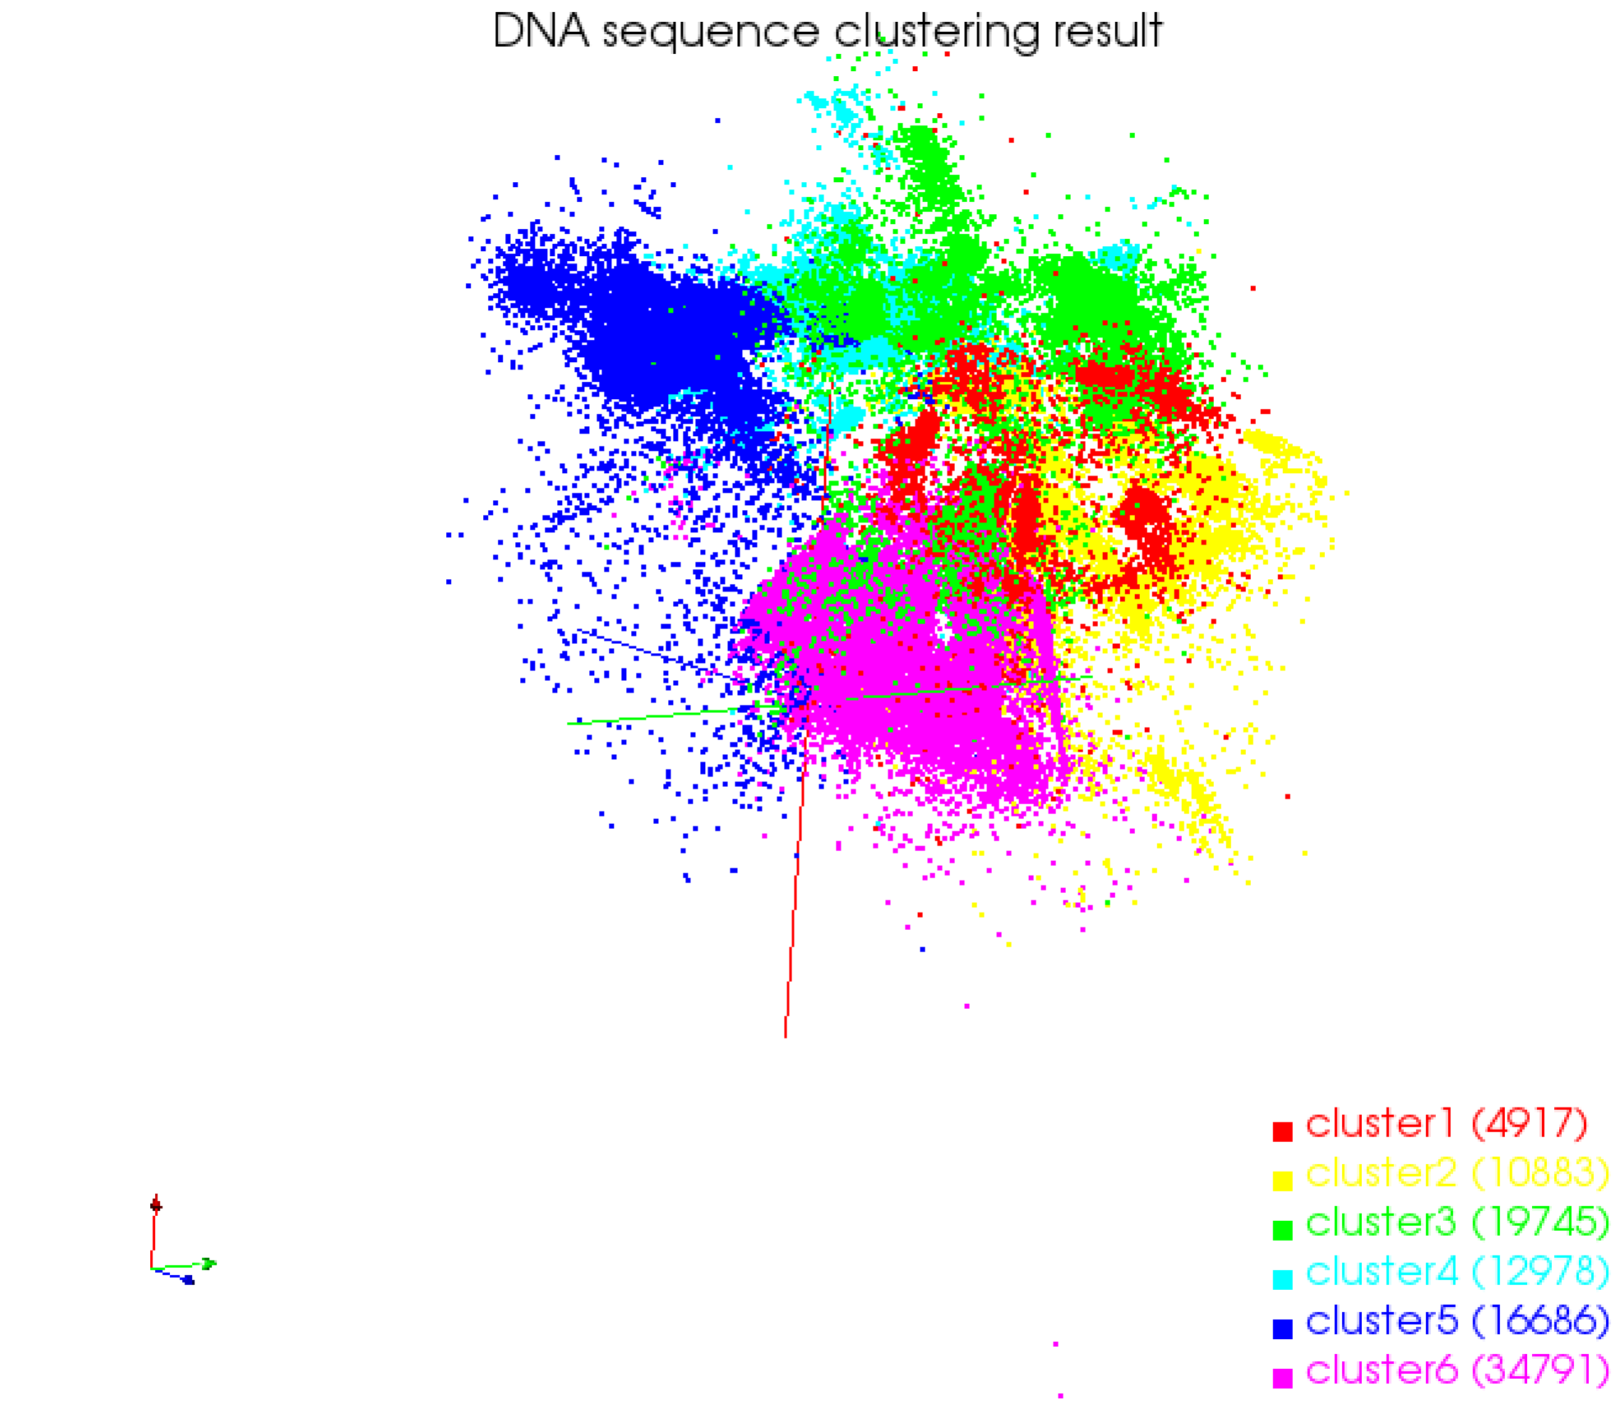

Fig. 5 3D clustering results based on combination of information bottle-neck theory and interpolation MDS corresponding to 100 partitions

The clustering results of 50 paritions are shown in 2D and 3D are shown as in figure 6 and 7.

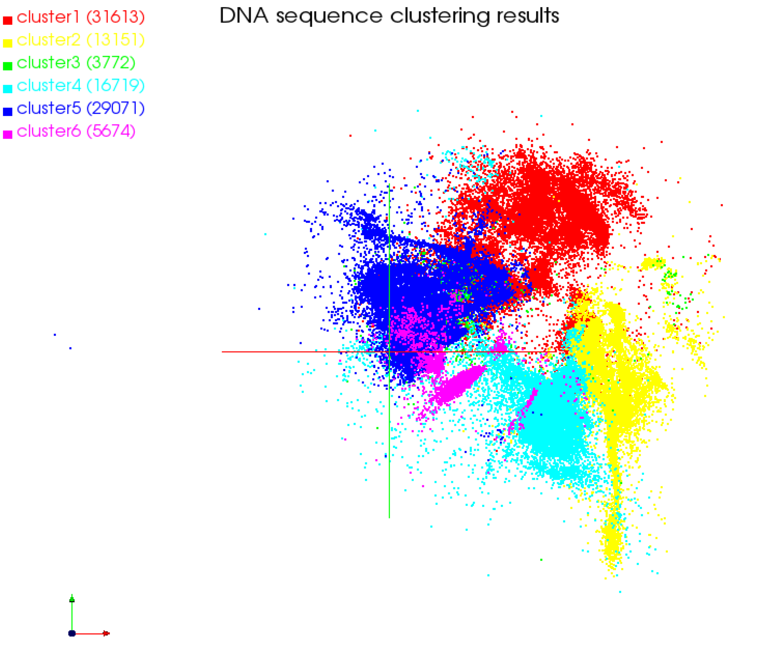

Fig. 6 2D clustering results based on combination of information bottle-neck theory and interpolation MDS corresponding to 50 partitions

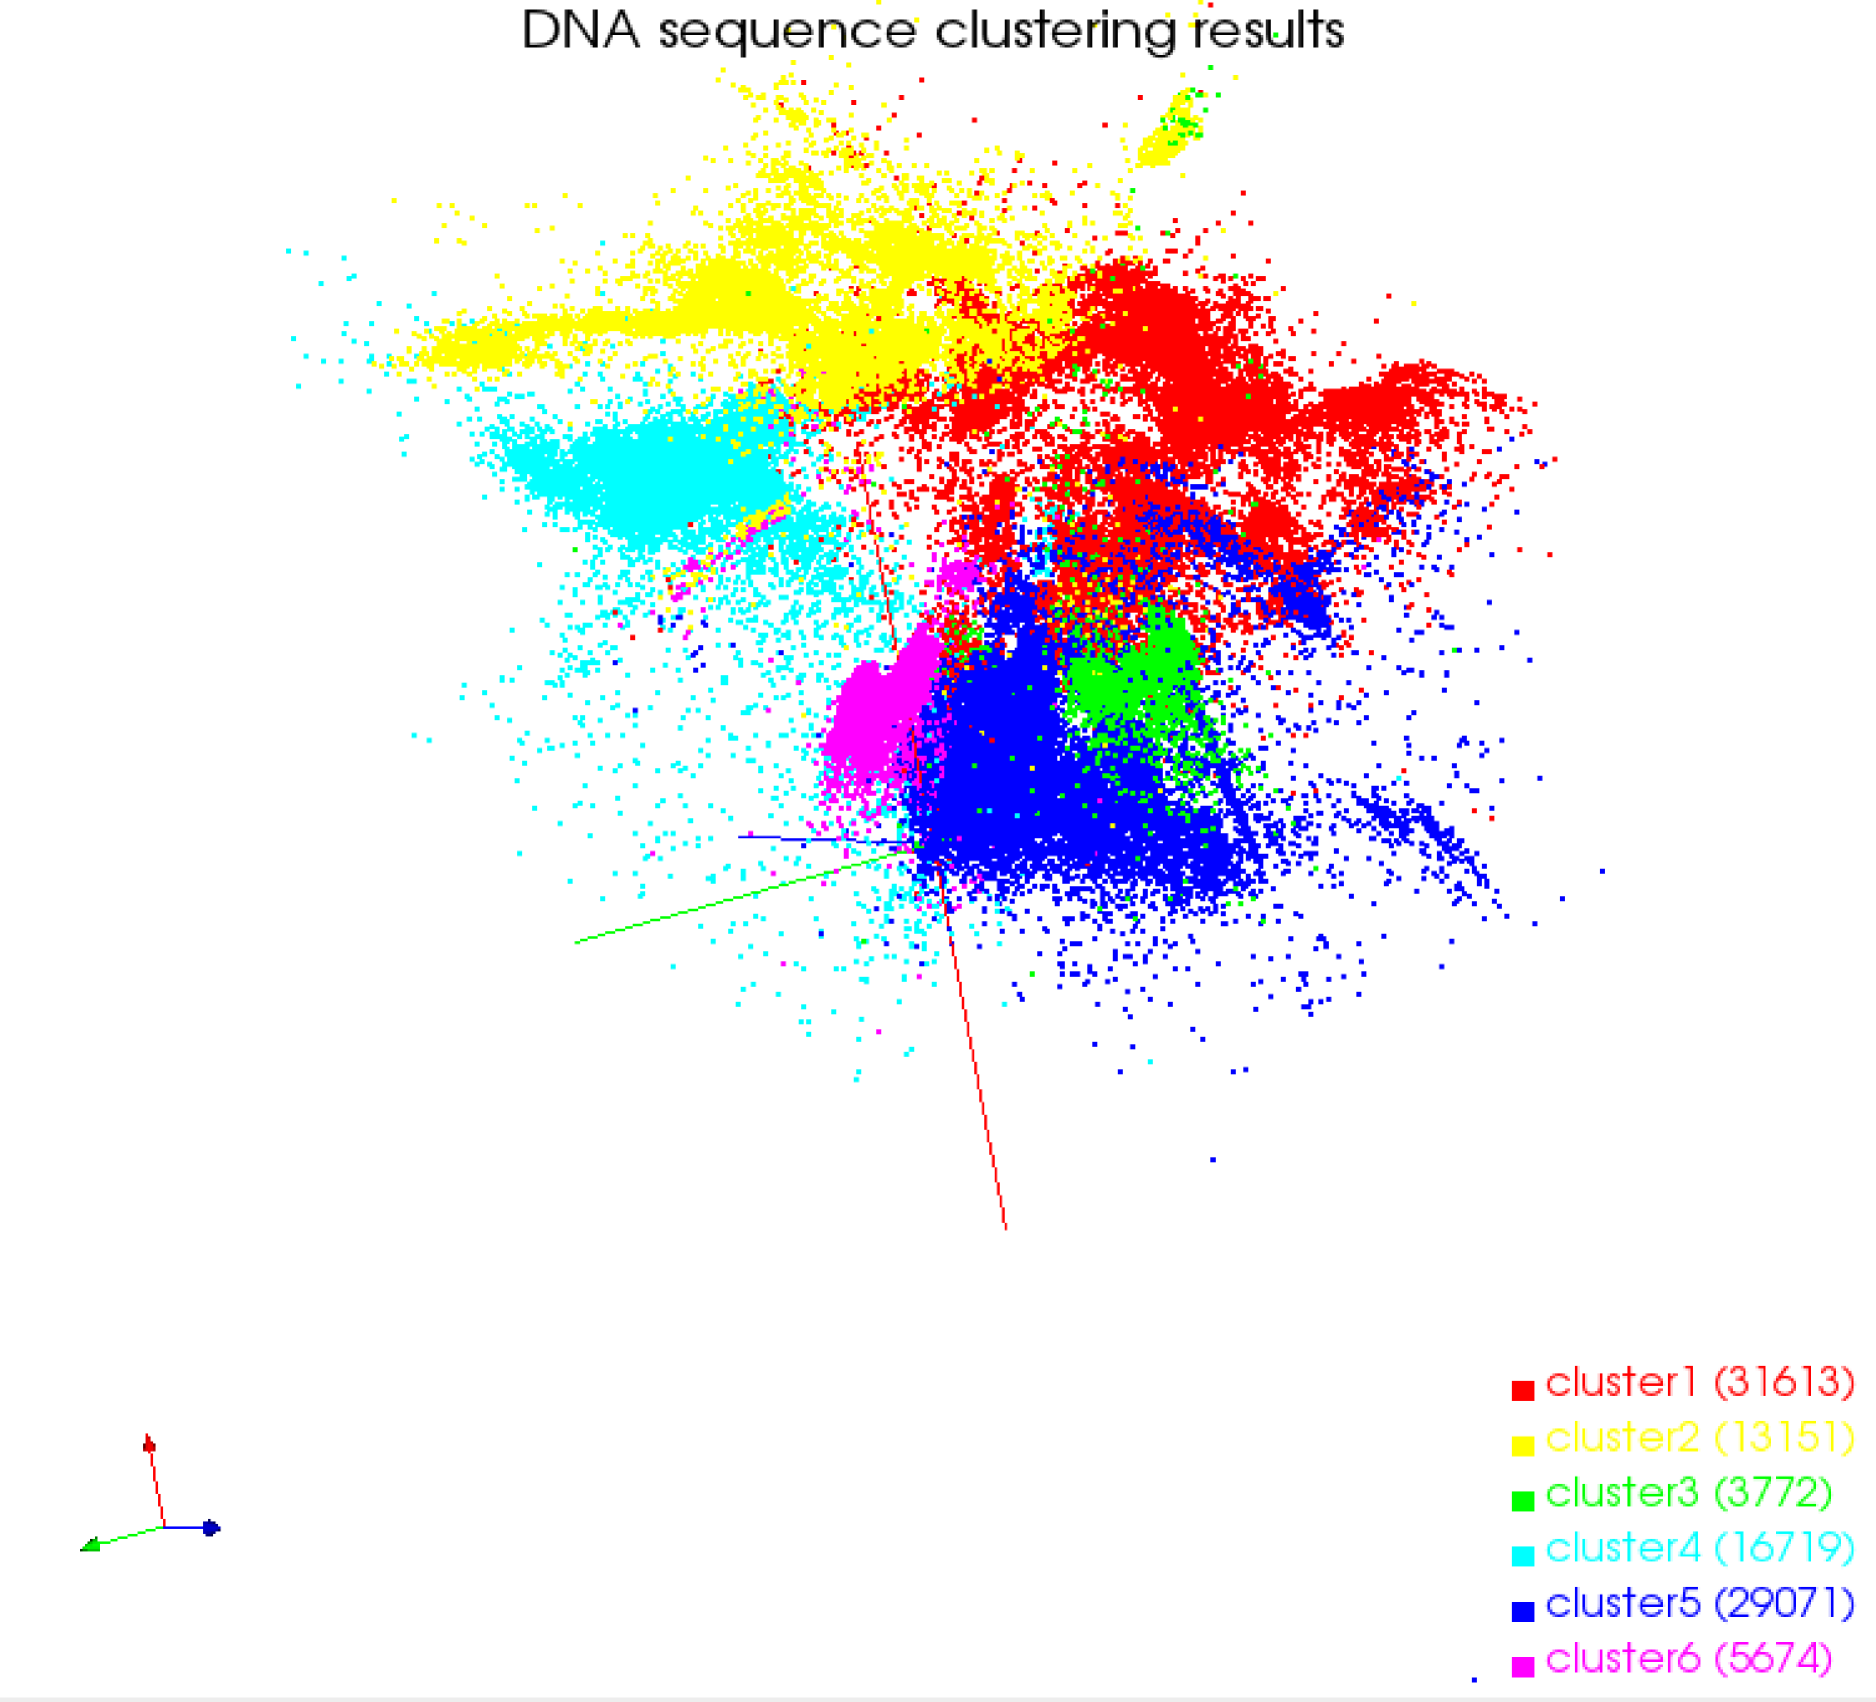

Fig. 7 3D clustering results based on combination of information bottle-neck theory and interpolation MDS corresponding to 50 partitions

**5.4 Clustering based on Kmeans**

For comparing the clustering results, parallel Kmeans based on MapReduce is used to analyze the example. Dataset is partitioned into 50 sections. The clustering number is set to 6 and the initial centroids are selected from the dataset randomly. The clustering results based on different initial centroid are different. Figure 8(a) and 8(b) are the clustering results based on Kmeans in 3D with different initial centroids.

From above visualization results, we can find that the clustering result based on the proposed method in this paper is better than that of parallel Kmeans method.

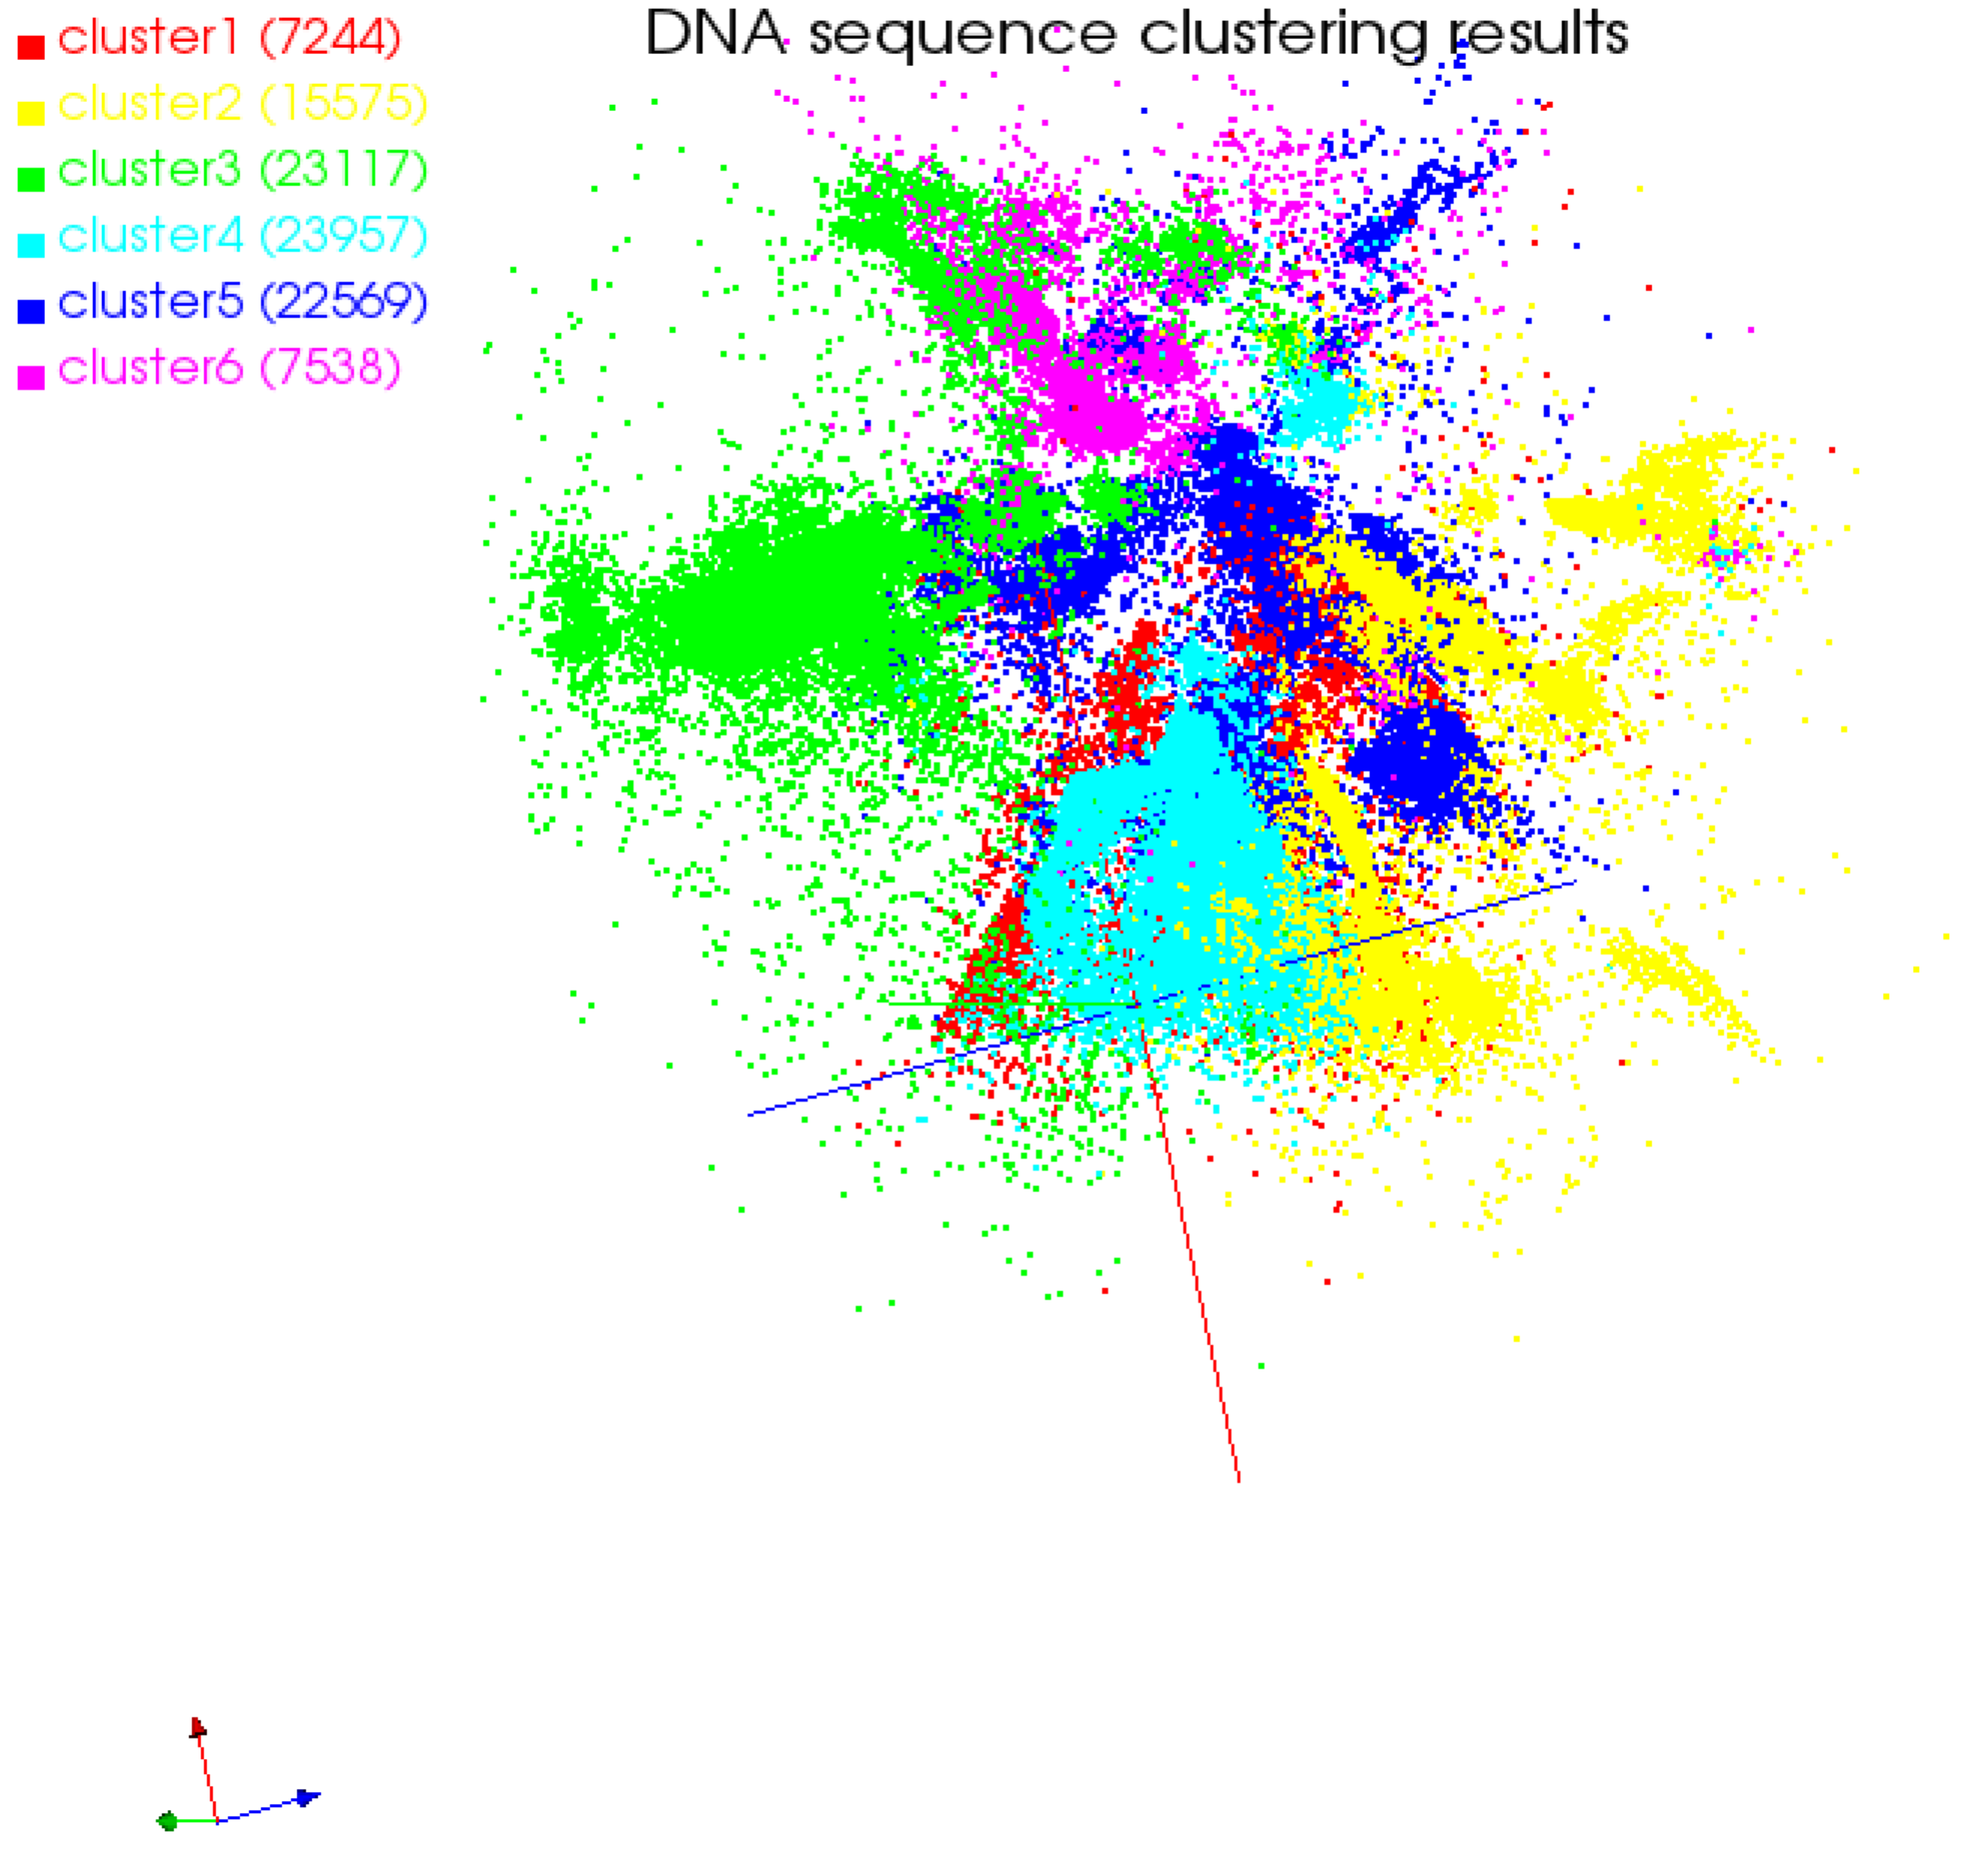

(a)

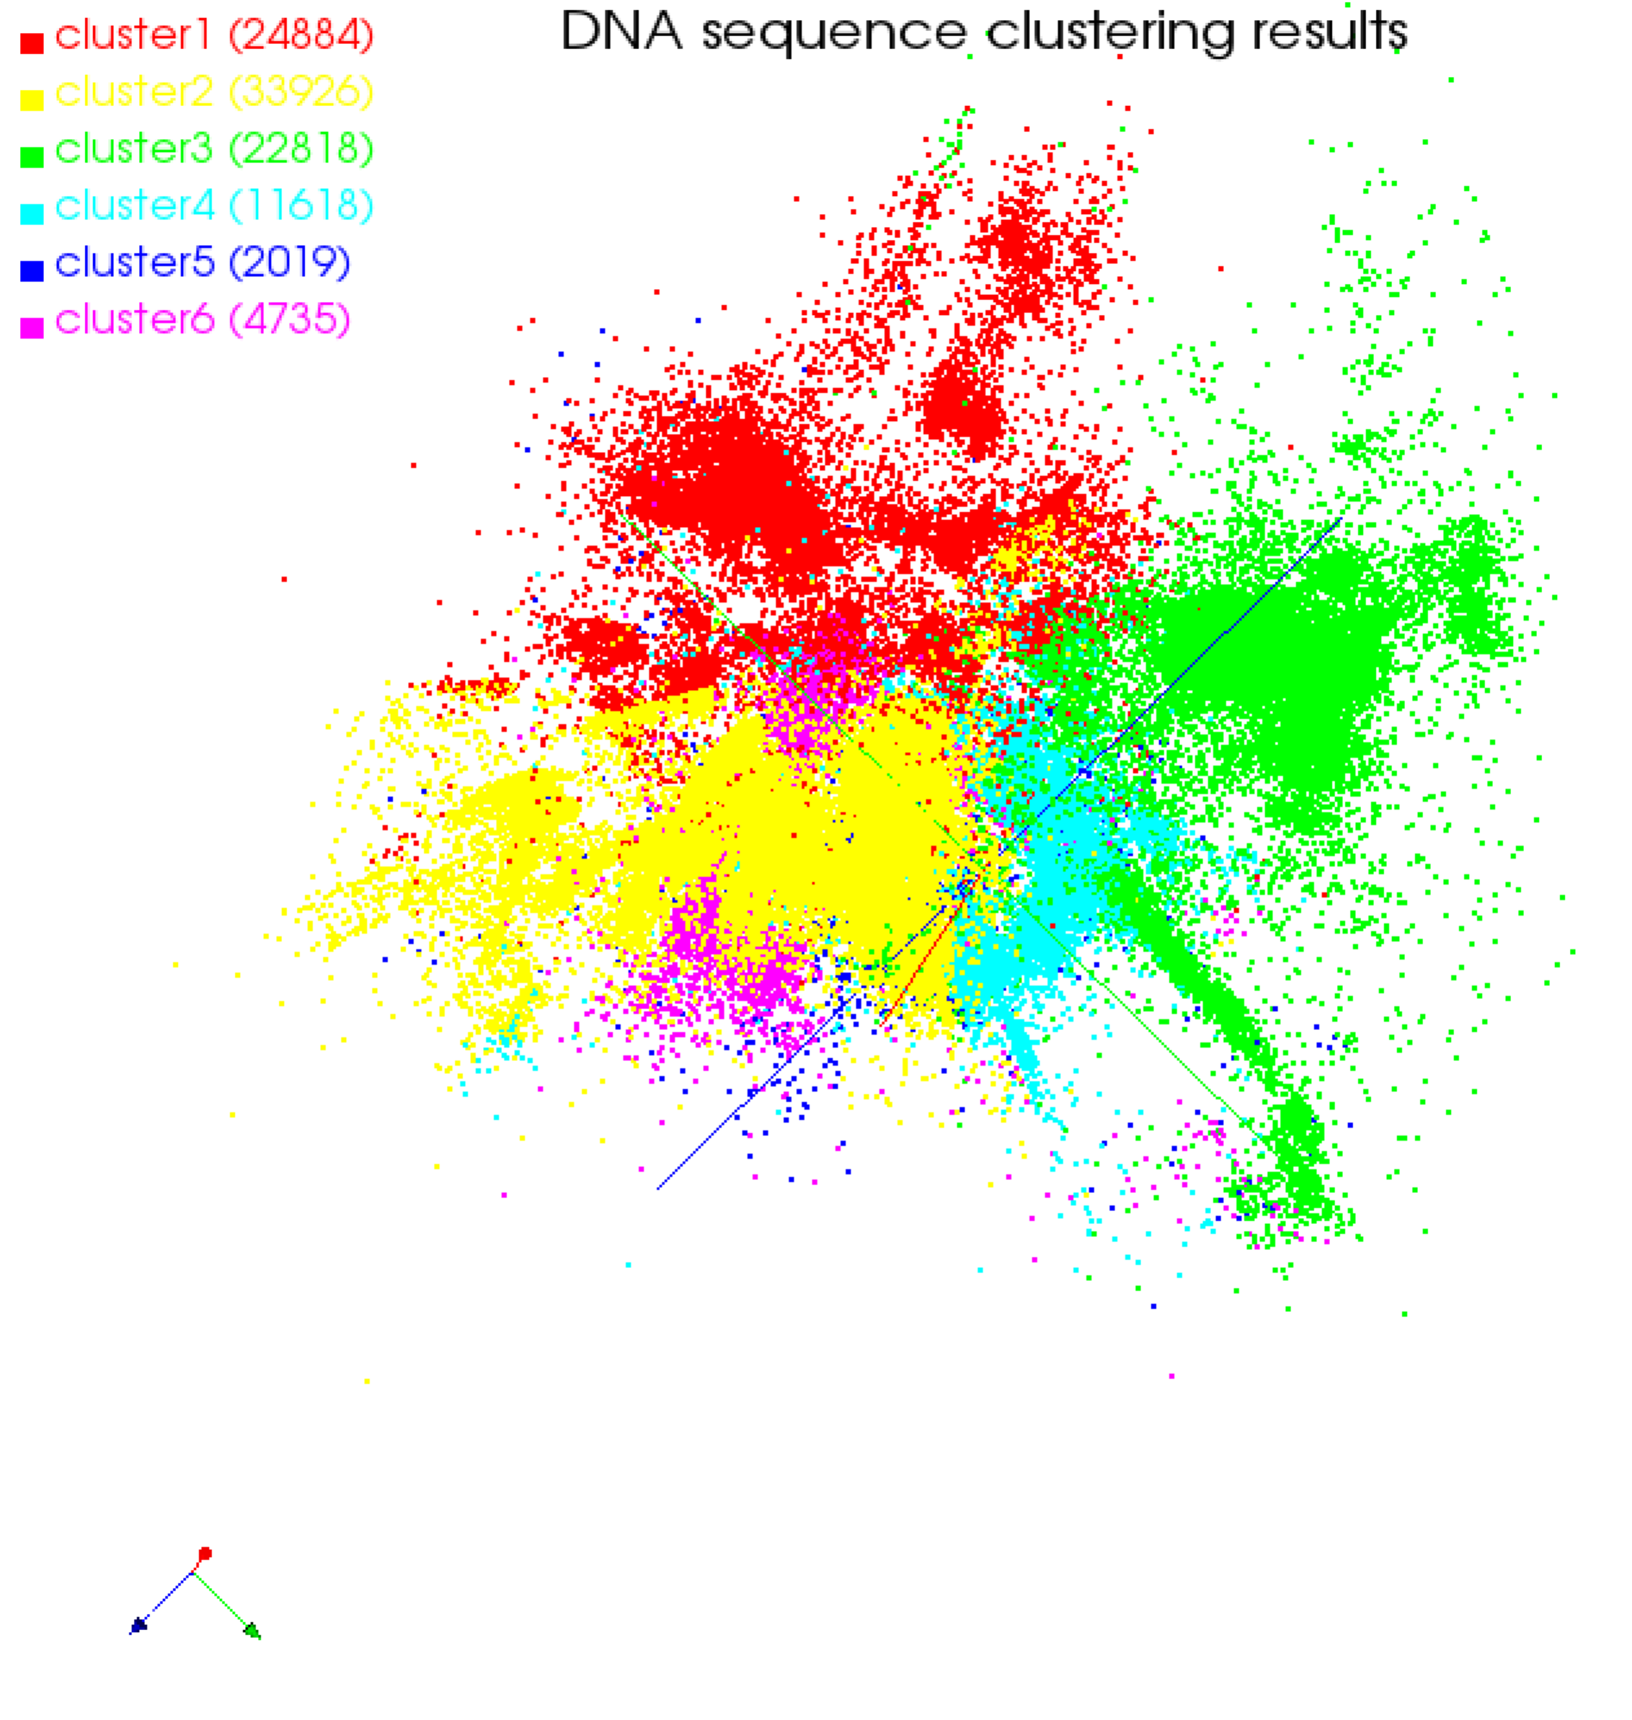

(b)

Fig. 8 3D clustering results based on Kmeans with different initial centroids

6 Conclusions

Large scale data clustering is an important task in many application areas. Efficient clustering method can reduce the computation cost markedly. The proposed clustering method in this paper is efficient for large-scale data analysis. It is based on MapReduce program model. It can increase the computation speed through increase partition number. On the other hand, the initial clustering centroid and the number of clusters can be determined according to an objective rule automatically. The DNA example analysis results show that the proposed method is scalable. The information loss is used to measure the distance between samples. It can measure any complicated statistical correlation between samples. Interpolation MDS is used to reduce the feature dimension of samples so that the clustering results can be visualized in 2D and 3D. The visualization clustering results of the example shows that the clustering result of the proposed method is better than that of Kmeans. Information loss based on mutual information can measure arbitrary statistic correlations. It provides a novel means to solve large scale clustering problems.

Acknowledgements

This work is partially supported by national youth science foundation (No. 61004115), national science foundation (No. 61272433), and Provincial Fund for Nature project (No. ZR2010FQ018).

References

1. M Ranjan, A D Peterson, P A Ghosh. A systematic evaluation of different methods for initializing the K-means clustering algorithm. Knowledge creation diffusion utilization, 2010: 1-11
2. K Sim, G E Yap, D R Hardoon et al. Centroid-based actionable 3D subspace clustering. IEEE Transactions on Knowledge and Data Engineering, 2013, 25(6): 1213 - 1226
3. N. Tishby, C. Fernando, W. Bialek, The information bottleneck method. The 37th Annual Allerton Conference on Communication, Control and Computing, Monticello, 1999: 1-11.
4. J. Coldberger, S. Gordon, H. Greenspan, Unsupervised image-set clustering using an information theoretic framework. IEEE transactions on image processing, 2006, 15(2): 449-457
5. N. Slonim, T. Somerville, N. Tishby, Objective classification of galaxy spectra using the information bottleneck method. Monthly Notices of The Royal Astronomical, 2001, (323):270-284
6. J R Swedlow, GZanetti, C Best. Channeling the data deluge. Nature Methods, 2011, 8: 463-465.
7. G C Fox, X H Qiu et al. Biomedical case studies in data intensive computing. [Lecture Notes in Computer Science](http://link.springer.com/bookseries/558), 2009, 5931: 2-18
8. Z Q Sun, G C Fox. Study on Parallel SVM Based on MapReduce. International Conference on Parallel and Distributed Processing Techniques and Applications, CSREA Press. 2012: 495-501
9. J A Blake, C J Bult. Beyond the data deluge: Data integration and bio-ontologies. Journal of Biomedical Informatics, 2006, 39(3), 314-320.
10. J Qiu. Scalable Programming and Algorithms for Data Intensive Life Science. A Journal of Integrative Biology, 2010, 15(4): 1-3
11. R Guha, K Gilbert, G C Fox, et al. [Advances in Cheminformatics Methodologies and Infrastructure to Support the Data Mining of Large, Heterogeneous Chemical Datasets](http://grids.ucs.indiana.edu/ptliupages/publications/Advances_in_Cheminformatics_Methodolo_3.pdf). Current Computer-Aided Drug Design, 2010, 6: 50-67.
12. C C Chang, B He, Z Zhang. Mining semantics for large scale integration on the web: evidences, insights, and challenges. SIGKDD Explorations, 2004: 6(2):67-76.
13. G C Fox, S H Bae, et al. Parallel Data Mining from Multicore to Cloudy Grids. High Performance Computing and Grids workshop, IOS Press, 2008: 311-340
14. J J Li, J Cui, D Wang, et al. Survey of MapReduce Parallel Programming Model. Acta Electronica Sinica, 2011, 39(11): 2635-2642.
15. J Ekanayake, H Li, et al. Twister: A Runtime for iterative MapReduce. The First International Workshop on MapReduce and its Applications of ACM HPDC, ACM press, 2010: 810-818
16. I T Jolliffe. Principal component analysis. New York: Springer, 2002.
17. K M George. Self-Organizing Maps. INTECH, 2010.
18. I Borg, J F Patrick. Modern Multidimensional Scaling: Theory and Applications. New York: Springer, 2005: 207–212
19. Seung-HeeBae, Judy Qiu, Geoffrey Fox. Adaptive Interpolation of Multidimensional Scaling. International Conference on Computational Science, 2012: 393-402
20. D. Ananstassiou. Frequency-domain analysis of biomolecular sequences. Bioinformatics, 2000, 16(12): 1073-1081.
21. B Liang, D Y Chen. DNA sequence classification based on ant colony optimization clustering algorithm. Computer Engineering and Applications, 2010, 46(25): 124-126.